**ETHERNET LAN USING N - NODES**

**Aim :**

Simulate an Ethernet LAN using n Nodes and Analyze the Throughput of the Network.

**Theory :**

**Ethernet**

Ethernet is a family of computer networking technologies commonly used in local area networks (LAN), metropolitan area networks (MAN) and wide area networks (WAN). It was commercially introduced in 1980 and first standardized in 1983 as **IEEE 802.3.** Ethernet has since retained a good deal of backward compatibility and has been refined to support higher bit rates, a greater number of nodes, and longer link distances. Over time, Ethernet has largely replaced competing wired LAN technologies such as Token Ring, FDDI and ARCNET.

The original 10BASE5 Ethernet uses coaxial cable as a shared medium, while the newer Ethernet variants use twisted pair and fibre optic links in conjunction with switches. Over the course of its history, Ethernet data transfer rates have been increased from the original **2.94 Mbit/s** to the latest **400 Gbit/s.** The Ethernet standards comprise several wiring and signalling variants of the OSI physical layer in use with Ethernet.

Systems communicating over Ethernet divide a stream of data into shorter pieces called frames. Each frame contains source and destination addresses, and error-checking data so that damaged frames can be detected and discarded; most often, higher-layer protocols trigger retransmission of lost frames.

Ethernet is widely used in homes and industry, and interworks well with Wi-Fi. The Internet Protocol is commonly carried over Ethernet and so it is considered one of the key technologies that make up the Internet.

**Local Area Network**

A local area network (LAN) is a computer network that interconnects computers within a limited area such as a residence, school, laboratory, university campus or office building. By contrast, a wide area network (WAN) not only covers a larger geographic distance, but also generally involves leased telecommunication circuits.

Ethernet and Wi-Fi are the two most common technologies in use for local area networks. Historical network technologies include ARCNET, Token ring, and AppleTalk.

Early Ethernet (10BASE-5 and 10BASE-2) used coaxial cable. Shielded twisted pair was used in IBM's Token Ring LAN implementation. In 1984, StarLAN showed the potential of simple unshielded twisted pair by using category 3 cable – the same cable used for telephone systems. This led to the development of 10BASE-T (and its twisted-pair successors) and structured cabling which is still the basis of most commercial LANs today.

While optical fibre cable is common for links between network switches, use of fibre to the desktop is rare.

In a wireless LAN, users have unrestricted movement within the coverage area. Wireless networks have become popular in residences and small businesses, because of their ease of installation. Most wireless LANs use Wi-Fi as it is built into smartphones, tablet computers and laptops. Guests are often offered Internet access via a hotspot service.

**Code : aftlan.tcl file**

#Create a simulator object

set ns [new Simulator]

#Define color for data flow (for nam)

$ns color 0 blue

#Open the nam trace file

set nf [open aftab.nam w]

$ns namtrace-all $nf

#Open a new file to log trace

set tf [open aftab.tr w]

$ns trace-all $tf

#Define a 'finish' procedure

proc finish {} {

global ns nf tf

$ns flush-trace

close $nf

close $tf

exec nam aftab.nam &

exec awk -f aftlan.awk aftab.tr &

exit 0 }

#Create ten nodes with color

set n0 [$ns node]

$n0 color red

set n1 [$ns node]

$n1 color red

set n2 [$ns node]

$n2 color red

set n3 [$ns node]

$n3 color red

set n4 [$ns node]

$n4 color red

set n5 [$ns node]

$n5 color red

set n6 [$ns node]

$n6 color red

set n7 [$ns node]

$n7 color red

set n8 [$ns node]

$n8 color red

set n9 [$ns node]

$n9 color red

set n10 [$ns node]

$n10 color red

#Create a local area network (LAN) of 10 nodes

$ns make-lan "$n0 $n1 $n2 $n3 $n4 $n5 $n6 $n7 $n8 $n9 $n10" 100Mb 20ms LL Queue/DropTail Mac/802_3

#Create TCP agent between node 0 and node 3

set tcp0 [new Agent/TCP]

$ns attach-agent $n0 $tcp0

set sink0 [new Agent/TCPSink]

$ns attach-agent $n3 $sink0

$ns connect $tcp0 $sink0

#Create FTP application for TCP agent

set ftp0 [new Application/FTP]

$ftp0 attach-agent $tcp0

#Specify TCP packet size

Agent/TCP set packetSize_ 1000

#Start and Stop FTP Traffic

$ns at 0.75 "$ftp0 start"

$ns at 4.75 "$ftp0 stop"

#Stop the simulation

$ns at 5.0 "finish"

puts "running nam"

$ns run

**Code : aftlan.awk file**

BEGIN {

sSize = 0;

startTime = 5.0;

stopTime = 0.1;

Tput = 0;

}

{

event = $1;

time = $2;

size = $6;

if(event == "+")

{

if(time < startTime)

{

startTime = time;

}

}

if(event == "r")

{

if(time > stopTime)

{

stopTime = time;

}

sSize += size;

}

}

END {

Tput = (sSize / (stopTime - startTime)) * (8 / 1000);

printf(" time : %f\t throughput : %.2f\n ", time, Tput);

}

**Screen Shots :**

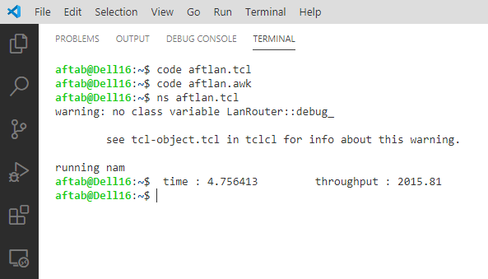

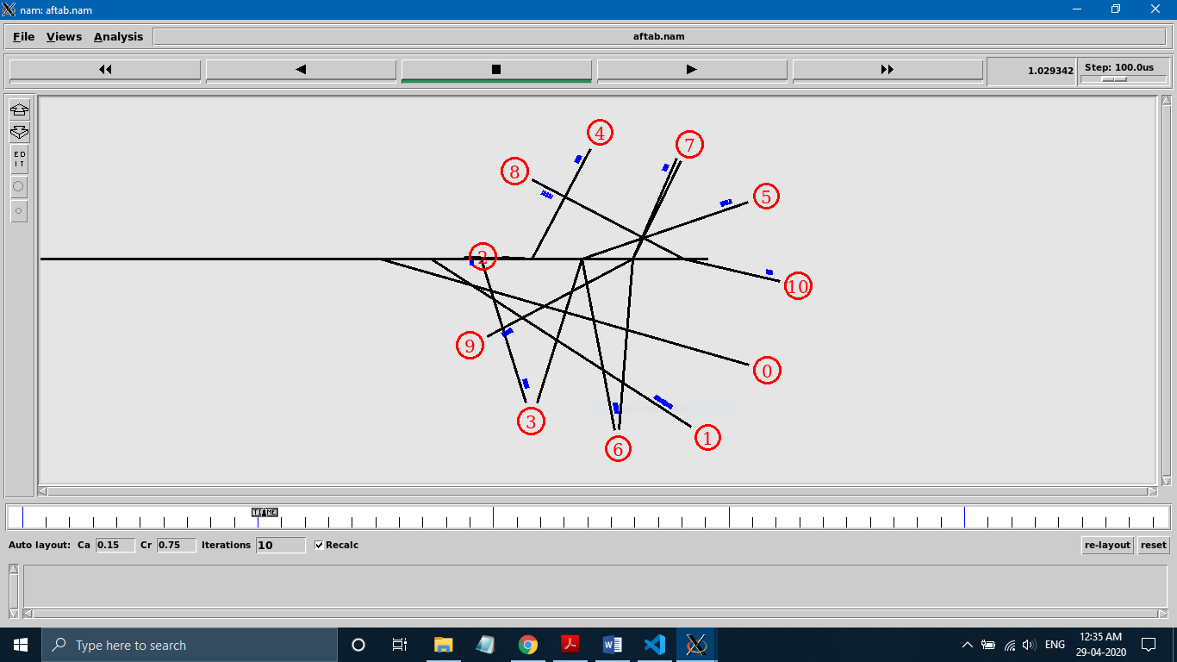

**Screen Shots :**

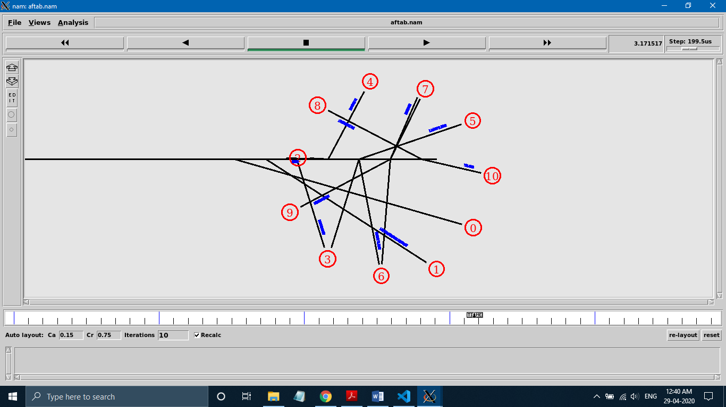

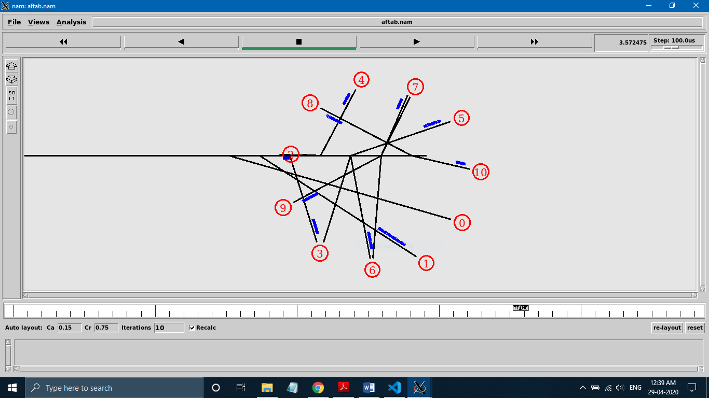

**Result :**

The Simulation of Ethernet LAN using n Nodes was Implemented and the Throughput of the Network was Analysed successfully.